**Full-Wave Uncontrolled Rectification**

A **full-wave uncontrolled rectifier** is a circuit that converts an AC (alternating current) input into a DC (direct current) output without using any control elements like thyristors. The rectification process is achieved using **diodes**, which allow current to flow only in one direction.

## **Types of Full-Wave Uncontrolled Rectifiers**

1. **Center-Tap Full-Wave Rectifier**
2. **Bridge Full-Wave Rectifier**

**---------------------------------------------------------------------------------------------------------------------------**

## **1. Center-Tap Full-Wave Rectifier**

This configuration uses a center-tapped transformer and two diodes to rectify the AC signal. The center tap serves as the reference (ground).

### **Working**

* During the positive half-cycle of the AC input, D1 conducts, and D2 is reverse-biased.
* During the negative half-cycle, D2 conducts, and D1 is reverse-biased.
* The output voltage is always positive and follows the shape of the rectified AC waveform.

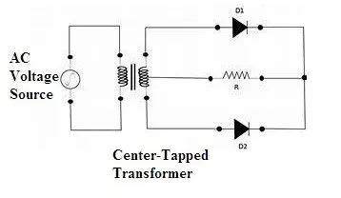

### **Formulas**

* Peak Output Voltage

**V(dc peak)=V(m)- V(D)**

**​**